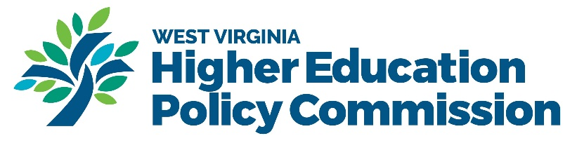
Quarterly Narrative Performance Report Template
Please submit your interim reports at the end of each quarter.
Please use the following template for your quarterly grant report. Check the appropriate box next to the deadline dates for the report you are submitting.

Midterm Report Deadlines
- Midterm Report 1- Deadline 6/30/2024 ☐
- Midterm Report 2- Deadline 9/30/2024 ☐
- Midterm Report 3- Deadline 12/31/2024 ☐
- Midterm Report 4- Deadline 3/31/2025 ☐
- Midterm Report 5- Deadline 6/30/2025 ☐
- Midterm Report 6- Deadline 9/30/2025 ☐
- Midterm Report 7- Deadline 12/31/2025 ☐

DOL Subgrantee Program Name:

Grant Number:

Program Year:

Name of person completing the report

Email/contact information of person completing the report

Date report submitted:

“The information provided in this Quarterly Narrative Performance Report will be used to help the Department of Labor’s (DOL) Employment and Training Administration (ETA) monitor the progress of the grant and identify promising practices and challenges of the grantee in implementing the grant. The information collected here provides a more comprehensive assessment of the progress of grantees in meeting expected milestones, performance indicators, and program requirements. It also provides additional qualitative information to ETA regarding the activities of grantees as it relates to Workforce Innovation and Opportunity Act (WIOA) implementation or implementation of other discretionary grant programs, timeliness of program deliverables, technical assistance needs, innovative or promising practices in the field, and the use of evaluation for program accountability, assessment, and improvement.”

Section I. Summary of Grant Activities
“The purpose of this section is to provide an executive summary of grant activities, including planned and actual progress. Grant activities should be aligned with the goals and objectives outlined in the grant Statement of Work (SOW) and ETA approved work plan/timeline.”
• Services supported by the grant- What services were conducted this quarter?
• Key activities completed, including partnership development and coordination-Services provided, do you have existing or partnerships/agreements to report this quarter?
• Additional activities performed by subgrantees, if applicable.

Section II. Progress towards SMART Goals

“The purpose of this section is to describe the progress of the grant’s project goals, benchmarks, milestones, special events, important deadlines, and deliverables.”
- What progress has been made towards SMART goals, the overall purpose of the subgrantee award, and program activities?
- Timeline summary- Provide a summary of the grant timeline and how your program is sticking with the timeline indicated in your grant application.
- Any challenges or concerns?

Section III. Development and Implementation

“The purpose of this section is to describe how the program model is achieving the program’s intended purpose and the goals/objectives and activities outlined in the grant application and work plan.”
- How do activities and programming contribute to use of services by underserved populations? For equitable services? Examples include:

• A description of outreach and/or recruitment activities;
• Examples of the development and implementation of education and training programs;
• Identifying and engaging industry sectors and employers;
• Aligning policies and programs;
• Measuring systems change and tracking performance;
• Developing new, or enhancing existing, curriculum or industry training; and
• Creating new career assistance tools and resources.

- Have there been any administrative barriers or challenges to ensure equitable use, for service delivery or achievement of outcomes?
- Subgrantees may also describe any lessons learned and how those lessons learned will be integrated into ongoing grant activities.

Section IV. Subgrantee Budget Update/Match Funds Summary
The purpose of this section is to provide budget updates for the subgrantee award and the status of all match funds and/or leveraged resources (if applicable). “Match resources are required resources, from non-Federal funds, that support the allowable grant activities. Leveraged resources are those additional resources the grantee and its partners use to support the implementation of the program. Leveraged resources may take the form of cash or in-kind donations. Please indicate any new leveraged resources used to sustain the project after the life of the grant, if applicable.”
- Report the cumulative amount of subgrantee grant funds utilized this quarter.
- Report any match and/or leveraged resources provided by the subgrantee and/or partners this quarter.

Section V. Strategic Partnership Activities
“The purpose of this section is to describe how partners are working together to implement the project and to communicate the dynamic growth and development of the strategic partnership, including cross-agency partnerships. This section is not intended to be a list of every partner meeting or communication, but rather should reflect the results and outcomes from such interactions and their impact on the project. Completing this section of the report allows grantees to reflect critically on their partnerships and contributes to broader discussions among grantees on partnership development and management.”
- Discuss how partners have engaged during the current phase of the project;
- Outline specific roles and contributions of each partner during this quarter;
- Identify any challenges encountered/resolved in the development and management partnerships;
- Report new partners that may have been included in the project, or identify any previous partners that may have left the project.

